**Introduction to HP ALM**

The various stakeholders involved in a typical project are –

•Developer

•Tester

•Business Analysts

•Project Managers

•Product Owners

These stakeholders perform diverse set of activities that need to be communicated to all concerned team members.

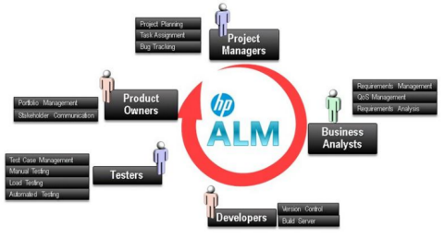

ALM evolution

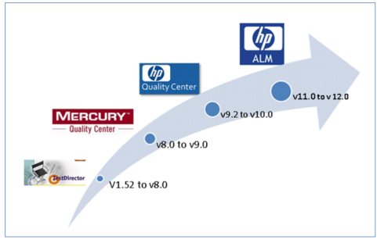

**Architecture of QC**

Now let us understand the technology part of HP-ALM. ALM is an enterprise application developed using Java 2 Enterprise Edition (J2EE) that can have MS SQL Server or Oracle as its back end. ALM has 3 components – Client, Application Server and Database Server.

1.**HP ALM client:** when an end user/tester accesses the URL of ALM, the client components are downloaded on the client's system. ALM client components help the user to interact with the server using .NET and COM technologies over a secured connection (HTTPS).

2.**ALM server/Application server:** Application server usually runs on a Windows or Linux platform which caters to the client requests. App server makes use of the Java Database Connectivity (JDBC) driver to communicate between the application server and database servers.

3.**Database servers**: The Database layer stores three schemas.

•**Site Administration schema:** It Stores information related to the domains, users, and site parameters.

•**Lab Project:** This schema stores lab information related to functional and performance testing on remote hosts, Performance Center server data.

•**Project schema:** Stores project information, such as work item/data created by the user under the project area. Each project has its own schema and they are are created on the same database server as the Site Administration schema.

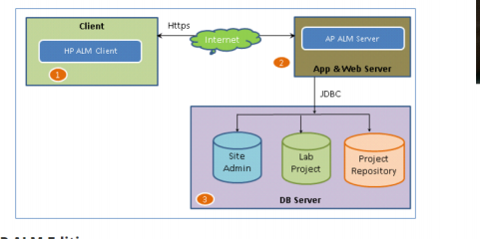 ALM WORKFLOW

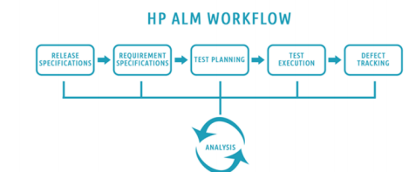**How to install HP ALM**

Installation process



http://www8.hp.com/us/en/software-solutions/alm-software-development-testing/try now.html

**Create a Domain, Project, User in HP ALM**

ALM client launch from IE

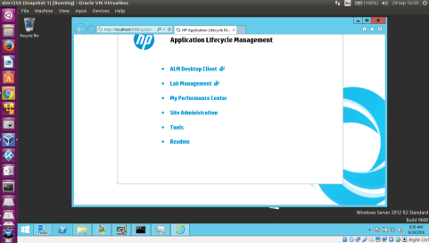Client interface

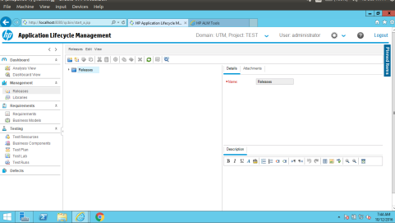

How to createEX_UTM domain

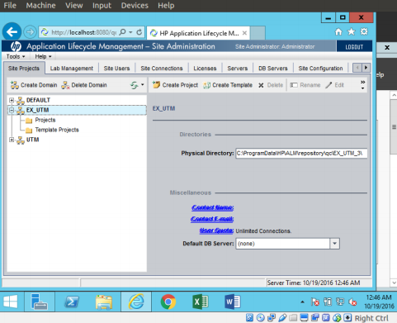

How to create project TESTARE1

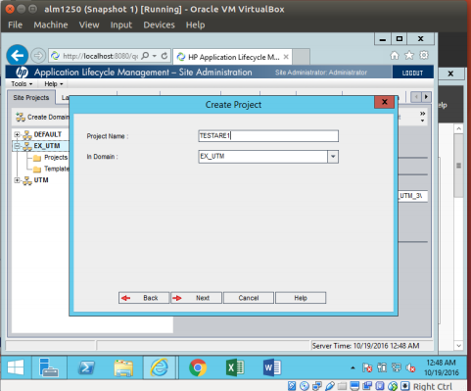

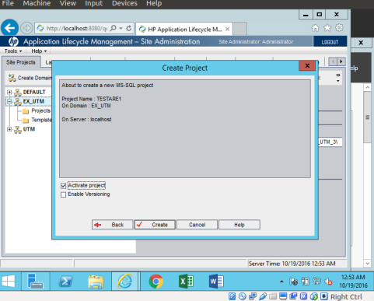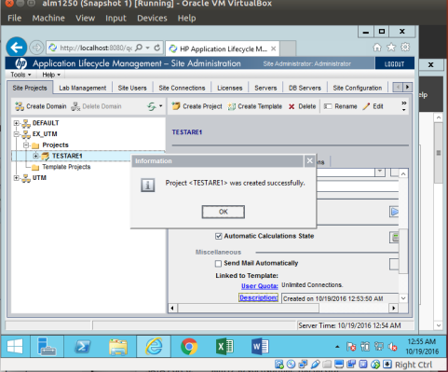

**Release Specifications:**

**Understanding the**

**Management Tab in HP ALM**

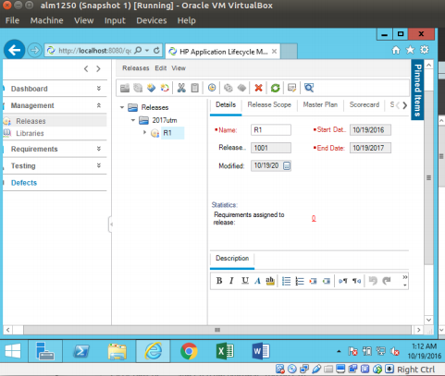

**Requirements Specifications module in HP ALM**

**Test Plan Module in HP ALM Test Lab in HP ALM**

**How to integrate UFT(QTP) with ALM**

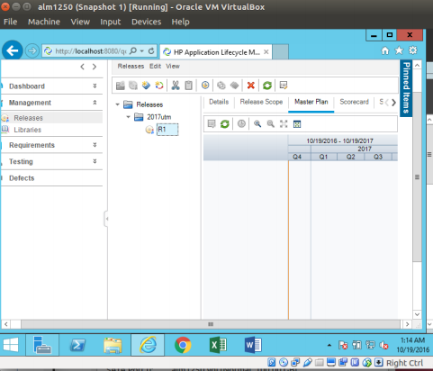

**Requirements Specifications module in HP ALM**

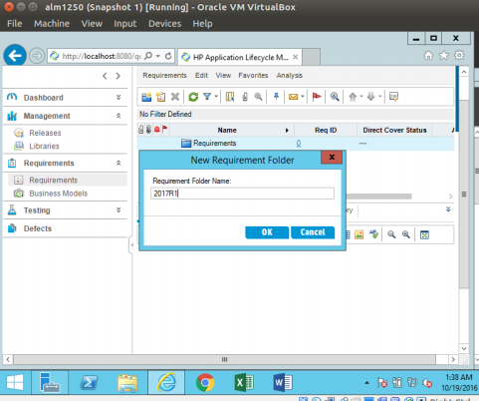

**Test Plan Module in HP ALM**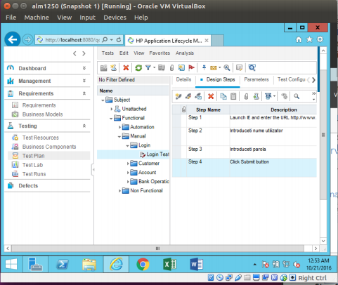

**Working with Test Lab in HP ALM**

